

XMICRO BUS
Technical Specifications
Table of Contents
1. Functional Description 3
1.1. Features: 3
1.2. Elements of a System 3
1.3. Signal Lines 4
2. Signalling 6
3. Electrical Specifications 8
3.1. Power Supply Characteristics 8
3.2. Signal Characteristics 8
3.3. Connectors 8
4. Physical Specifications 8
4.1. Cards 9
4.2. Backplanes 9
Illustration Index
Illustration 1: Bus Connector Pinout 4
Illustration 2: Card Physical Dimensions 10
Illustration 3: Backplane Physical Dimensions 11
Index of Tables
Table 1: Signal Sources 6
Table 2: Bus Driver Output Topologies 8

Functional Description

Features:
- 8-bit Data Field Width
- 1 Megabyte Memory Address Range
- I/O-mapped I/O
- Asynchronous Data Transfer
- Multiple Masters
- Position Independence of Cards in Backplane
- Automatic position-based Resource Allocation
- Hardware Self-Discovery and Configuration
- Main Memory Inhibit Signal
- CPU Architecture Independence
- ATX Power Supply Compatibility
- Standard 62-pin Card Edge Connector
- Fully Open-source

Elements of a System
An XMICRO system consists of the following elements:

- Backplane
- Primary Master
- Secondary Masters
- Slaves

An XMICRO Backplane is the basis of any system. In its simplest form, the backplane handles power and signal distribution, and card-specific signal routing. Typically it should also include an I/O address decoder, and a power-on reset circuit. More complex implementations may add significantly more functionality, including peripherals or an onboard CPU. When a primary master is built into a backplane, it should be referred to as a motherboard.

A Primary Master is a card or motherboard which acts as the default system controller. Typically this will be the main “CPU” card. In the context of this document, the “system controller” is the device driving the A<19..0>, RD, WR, and FETCH signals. Primary masters must default to this operation unless the bus is requested by another device. Only primary masters handle interrupt signals and bus requests.

A Secondary Master is a card with the ability to act as a temporary system controller. This is generally used for DMA operations by the secondary master, independent of the primary master.

A Slave is a card with no ability to control the system. Slaves are only capable of reading/writing data under the command of a master.

Note: The master/slave designation is somewhat loose and is used only as a broad classification of the functionality of a device. It may be used to refer to either a discrete subsystem or a card as a whole.

Signal Lines
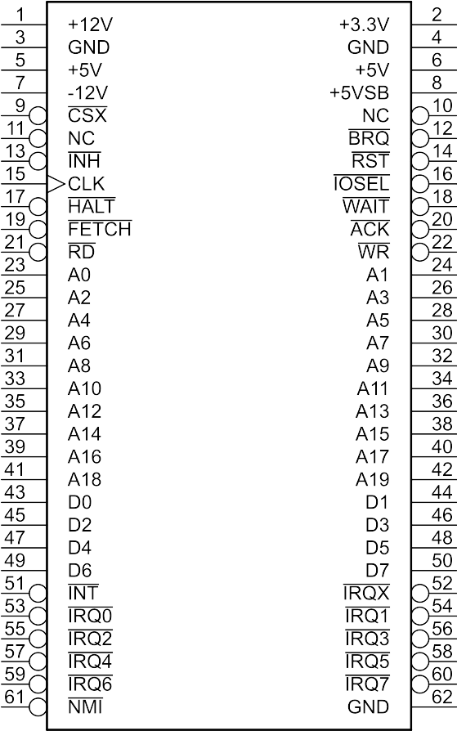Illustration 1: Bus Connector Pinout
Power Supply Rails (+12V, +5V, +5VSB +3.3V, GND, -12V)
These lines supply power to the bus. Current capacity is defined by the backplane’s specifications, however it is not recomended to exceed 1.5A per card on any rail. If more current is required, an external power connection should be added to the card. Voltage tolerances match the ATX standard. It is recommended that a standard ATX power supply be used.

Address Lines (A<19..0>)
Twenty unidirectional lines driven by the master to specify a memory or I/O location.

Data Lines (D<7..0>)
Eight bi-directional lines which carry information between master and slave devices.

Read Strobe (RD)
Asserted by the master to indicate that the addressed slave device may place data on the data lines.

Write Strobe (WR)
Asserted by the master to indicate that it has placed data on the data lines.

I/O Select (IOSEL)
Asserted by the master to access the backplane’s card I/O space. When asserted, A<11..8> determine which backplane slot is being addressed.

Reset (RST)
This open-collector signal resets the system into a known state. During the power-on sequence, this signal should be asserted by the backplane until at least 250ms after all power supply rails have stabilized.

System Clock (CLK)
This signal is the main system clock. Care should be taken to ensure it is a clean square wave. Its frequency and duty cycle are undefined. The primary master should typically provide this signal, however it may optionally be provided by another card such as a video card. It is recommended that primary masters do not strictly require externally generated clock signals to function.

Wait (WAIT)
This open-collector line is asserted to inform the master that the current data operation is not yet ready for completion. The master should wait until this signal is released to continue. Not to be confused with HALT.

Halt (HALT)
This line is asserted by the primary master to indicate to that it is in a halted state and waiting for an interrupt. Not to be confused with WAIT.

Instruction Fetch (FETCH)
This signal is asserted by the primary master when the current data transfer operation is an instruction fetch.

Main Memory Inhibit (INH)
This slot-independent line is used to inhibit general-purpose main memory. When INH is asserted, main memory must be prevented from reading or writing data, or driving the bus. This precludes the need for special hardware configuration when using devices requiring additional address space.

Bus Request (BRQ)
This slot-independent line is driven by a secondary master to request control of the bus. When the primary master is ready to release control of the bus, it will assert ACK.

Bus Acknowledge (ACK)
This signal is held low by the primary master to indicate that it has released the bus for control by a secondary master. The secondary master may only control the bus while this signal is asserted.

Card Select X (CSX)
This slot-specific signal is driven by the backplane to indicate that the current address is within the range of the slot’s allocated address space. While this signal is asserted, A<19..8> may be ignored by the card because their state is known. Note: this is a discreet signal for each card slot, provided by the backplane.

Interrupt Request X (IRQX)
This slot-specific line is driven by a card to indicate that it requires the primary master’s attention. It is routed to the appropriate input by the backplane. This allows for interrupt vectoring and prioritization based on card position. This is a level-triggered interrupt signal.

Interrupt Request (IRQ<7..0>)
These eight lines are driven by cards 7-0 through the IRQX signal. They are used by the primary master for interrupt prioritization and vectoring. Under no circumstances are these lines to be driven directly by a card.

Interrupt (INT)
This open-collector signal is used for special purposes where it is necessary to bypass a primary master’s onboard interrupt handling circuitry. Typically this is only used to expand interrupt capabilities on backplanes with more than eight slots. Primary masters must accept this signal, either by including it in their interrupt handling scheme or combining it with the CPU’s raw interrupt input. This is a level-triggered interrupt signal.

Non-maskable Interrupt (NMI)
Open-collector edge-triggered interrupt signal. Its use is unusual, so it is recommended that this signal be optional on any card using it. NMI should only be used for special signals requiring the immediate attention of the primary master, such as memory errors, power failure, or video timing. When possible, primary masters should give this signal an immediate priority override of in-progress interrupts and DMA transfers.

Unused Pins (NC)
These pins are not currently used and their use is reserved for future revisions of this specification. These should be individually connected and terminated on the backplane similarly to other signals.

Signalling

Table 1: Signal Sources
Signal | Driver | Receiver
A<19..0> | Master | Any
D<7..0> | Master (WR), Slave (RD) | Slave (WR), Master (RD)
RD | Master | Any
WR | Master | Any
IOSEL | Master | Backplane, Memory Systems
CLK | Master (Typ.) | Any
HALT | Master | Any
FETCH | Master | Any
ACK | Master | Secondary Master
CSX | Backplane | Cards
RST | Any | Any
WAIT | Any | Master
INH | Any | Memory Systems
BRQ | Secondary Master | Primary Master
IRQX | Any | Primary Master
IRQ<7..0> | Backplane | Primary Master
INT | Backplane | Primary Master
NMI | Any | Primary Master
NC | None | None

WAIT Signal

The WAIT signal is asserted by a slave device to indicate that a data transaction is not yet ready to be completed. If RD or WR is asserted while WAIT is asserted, the master must hold A<19..0>, D<7..0>, IOSEL, RD, and WR stable until after WAIT is deasserted.

Bus Arbitration

In the system’s default state, a primary master takes full control of the system bus. By asserting the BRQ line, a secondary master may request to temporarily take over control of some of the bus signals in order to directly access memory. When BRQ is asserted, the primary master gracefully pauses operation

The ACK signal indicates that the primary master has placed the following signals in a high-impedance state:

- A<19..0>
- D<7..0>
- RD
- WR

These signals may be driven by a secondary master only while ACK is asserted.

If the ACK signal is de-asserted before the secondary master de-asserts BRQ, the secondary master must release the bus signals and wait until ACK is once again asserted to continue the operation. The secondary master may terminate the operation early.

In order to prevent bus contention, secondary masters should wait for a command from the primary master before initiating a bus request, and must not initiate a bus request until the BRQ (and ACK?) signals are no longer asserted.

Electrical Specifications

Power Supply Characteristics
- A backplane must supply cards with the following voltages: +3.3V, +5V, +12V, -12V, +5VSB.
- Specifications of the power supply are to match the ATX standard.
- The use of an ATX power supply is recommended.
- Cards requiring significant supply current may also use standard 4-pin male Molex 8981 connectors to supplement the +5V and +12V rails. Unless isolated, these must be supplied by the same power supply system and must not conflict with the backplane’s supply rails.

Signal Characteristics
- A receiver must recognize a voltage of ≤ 0.8V as a logic 0, and a voltage of ≥ 2.0V as a logic 1.
- The minimum sink current capability of any driver on any line must be 24mA at 0.5V. Further, it is recommended that drivers with minimum source capability of 24mA at 2.4V be used.
- The minimum rise and fall transition times (10%-90%) of any line driving device must be > 5ns when driving a capacitive load of 45pF.

Table 2: Bus Driver Output Topologies
Signal | Output Device
A<19..0> | Tri-state
D<7..0> | Tri-state
RD | Tri-state
WR | Tri-state
IOSEL | Tri-state
CLK | Push-pull
HALT | Push-pull
FETCH | Push-pull
ACK | Push-pull
CSX | Push-pull
RST | Open-collector
WAIT | Open-collector
INH | Open-collector
BRQ | Open-collector
IRQX | Open-collector
IRQ<7..0> | Open-collector
INT | Open-collector
NMI | Open-collector

Connectors
- The average current on any connector pin must not exceed 1A.

Physical Specifications

Cards
- Cards must connect to the backplane using a 62-pin 0.1 inch pitch card edge connector.
- Card edges must be 3.186” ±0.014” in length and 0.3” in height.
- Card edges should be gold-plated for better reliability. HASL or similar surface finishes are discouraged.
- Card edges should be chamfered for easier insertion.
- A card’s dimensions must not exceed the overall dimensions shown in Illustration 2
- The use of standard “full-size” and “half-size” card form-factors is strongly encouraged.
- Standard card mounting holes should be isolated from the backplane’s GND pins and treated as a discreet chassis ground if conductive.

Backplanes

Illustration 2: Card Physical Dimensions
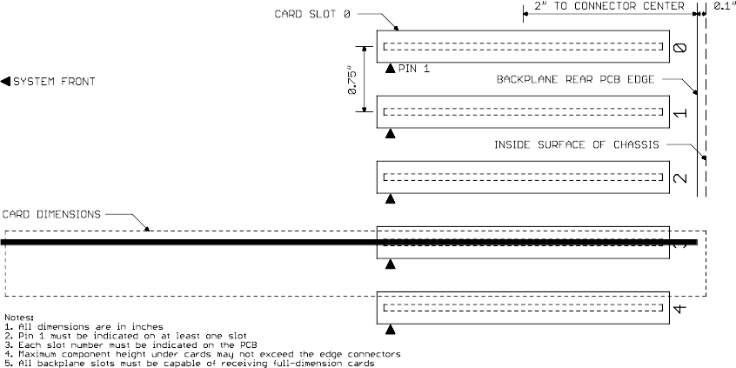Illustration 3: Backplane Physical Dimensions

